PocketSmart AI: Your Smart Budget & Recommendation Assistant - Complete Project Documentation

Project Description
Managing budgets across different life needs—like home decor, event planning, or jewelry shopping—can be overwhelming due to the wide variety of products, platforms, and price ranges. PocketSmart AI addresses this challenge through a GenAI-powered, cross-platform recommendation system that delivers personalized, budget-based suggestions for products and services. Using Gemini 1.5 Flash Pro, PocketSmart AI analyzes user preferences, budgets, and contextual needs to generate curated recommendations from popular platforms such as Amazon, Flipkart, IKEA, Swiggy, Zomato, OYO, and more. The platform helps users plan interior designs, parties, and even select matching jewelry for special occasions—all within their defined budgets. PocketSmart AI transforms budgeting into an intelligent, user-friendly experience through its smart planners, adaptive forms, and recommendation engine that bridges multiple categories and e-commerce ecosystems.

Detailed Scenario Walkthroughs

Scenario 1: Home Interior Planning with Smart Budget Allocation
Users begin by selecting the Home Budget Planner. After entering their budget, they specify room types (e.g., Living Room, Kitchen, Bedroom) and quantities for lights, ceiling fans, dining tables, etc. Gemini 1.5 Flash Pro processes this data and recommends cost-effective options for each category across platforms like IKEA and Amazon. Recommendations are balanced across functionality, style, and price, ensuring users can decorate their spaces beautifully without overspending.

Scenario 2: AI-Based Party Budget Planning
In the Party Planner, users input their total budget, guest count, event type, and venue details. Based on these inputs, the AI allocates the budget proportionally across catering, decoration, and entertainment, sourcing options from vendors listed on Swiggy, Zomato, and even accommodation services like OYO. The system tailors suggestions based on event type (e.g., birthday, corporate, wedding), helping users organize a successful event without financial guesswork.

Scenario 3: Jewelry Recommendations for Occasions
The Jewelry Budget Planner allows users to enter a budget, select the occasion, and define style preferences. Users can optionally upload an outfit image for the AI to consider color coordination and aesthetics. Gemini 1.5 Flash Pro analyzes the data and offers jewelry options from platforms like Amazon and Flipkart, tailored to occasion and style. This ensures that users receive elegant, matching jewelry suggestions that fit both their personal style and financial plan.

Architecture Overview
PocketSmart AI is an intelligent, modular platform designed to generate personalized, budget-aware recommendations across domains like home interiors, party planning, and jewelry selection. It integrates a lightweight FastAPI backend with Google's Gemini 1.5 Flash Pro, a powerful multimodal AI model that processes user inputs (text, numbers, and images) to deliver smart recommendations.

Core Technologies
- FastAPI: Backend service layer for asynchronous request handling, routing, session control, and API endpoint configuration.
- Gemini 1.5 Flash Pro: AI model used for understanding budget context, analyzing images, generating structured suggestions, and recommending platform-specific products.
- Third-party APIs / Integration Links: Product and service data mapping for Amazon, Flipkart, IKEA, Zomato, Swiggy, BookMyShow, Ajio, Myntra, etc.
- Frontend (HTML/CSS + Jinja2 Templates + JavaScript): Interactive user interface for input collection and AI output display.

Component-Wise Architecture Table
Component | Description
Frontend UI | Web interface built with HTML/CSS allowing users to input budgets, preferences, and images. Displays tailored AI-driven recommendations for each category.
FastAPI Backend | Manages user sessions, routes (/home-budget, /party-budget, /jewelry-budget), and handles communication between UI and Gemini AI.
Gemini AI Layer | Processes inputs using Gemini 1.5 Flash Pro to evaluate constraints, analyze outfit aesthetics, and structure multi-category suggestions.

Project Workflow & Implementation Guide

Milestone 1: Gemini AI Initialization & Setup
In this foundational stage, the objective is to establish and configure the core AI infrastructure required to power PocketSmart AI. The platform relies on Gemini 1.5 Flash Pro—Google's multimodal foundation model to interpret user inputs, process budgets, and generate personalized recommendations.
- Activity 1.1: Set up Google Cloud account and enable Gemini API
  - Sign in or create a Google Cloud account via console.cloud.google.com.
  - Navigate to Google AI Studio to accept terms and conditions and click on Get API key.
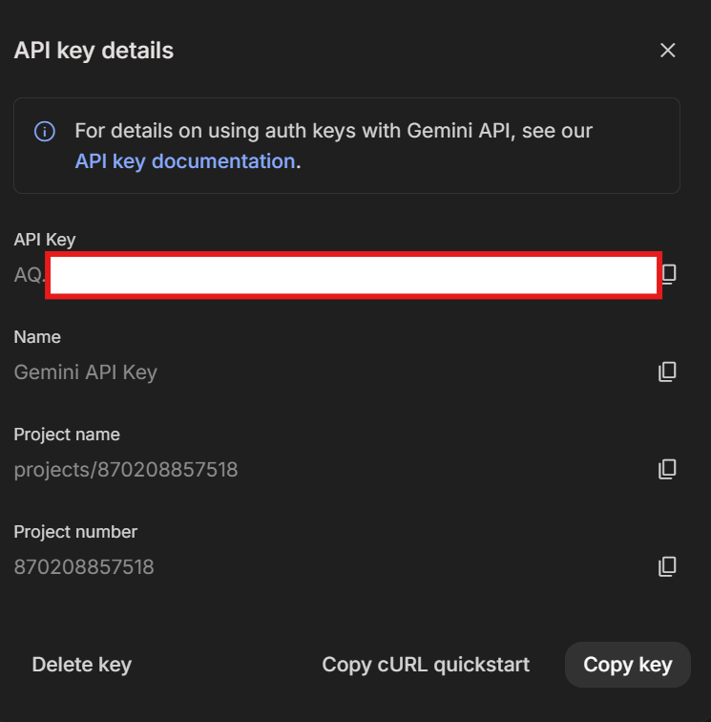
- Activity 1.2: Configure Access and Permission
- Copy your generated API key and securely add it to your project configuration environment (.env).
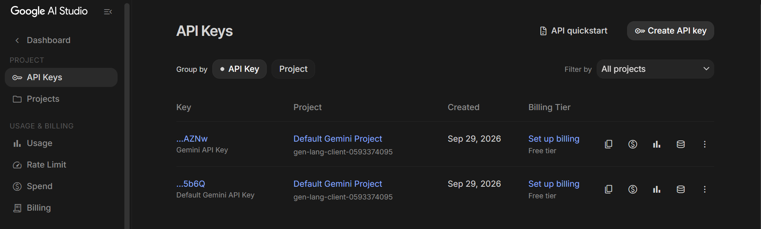

- Activity 1.3: Validate Gemini API connectivity
  - Make a sample prompt call using Python to confirm integration.
  - Test both text-only and image + text prompts to ensure multimodal compatibility.
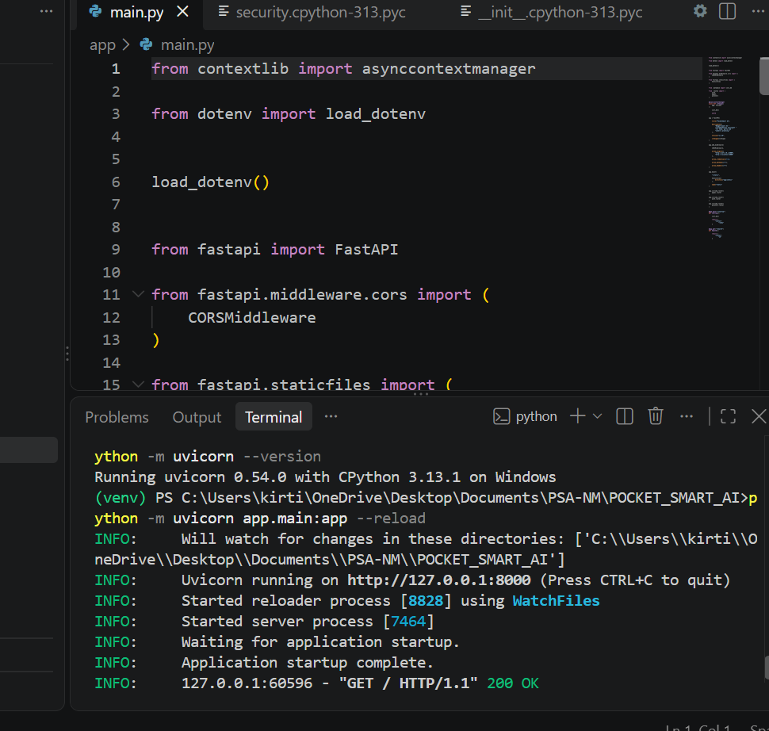
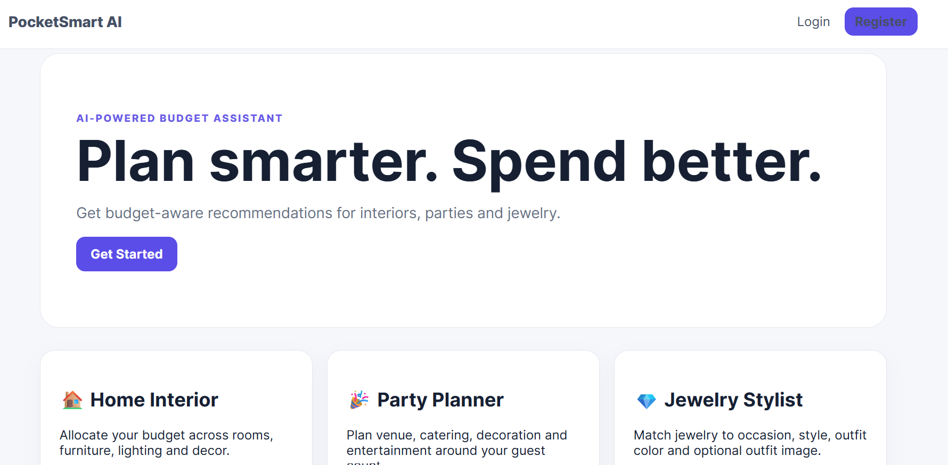

Milestone 2: Core Functionalities Development
This milestone focuses on building the core backend intelligence of PocketSmart AI using the FastAPI framework and Google's Gemini 1.5 Flash Pro foundation model.
- Activity 2.1: FastAPI Initialization and Import Libraries
  - Import all required modules (os, json, fastapi, google.generativeai, pydantic, passlib, etc.).
  - Initialize the FastAPI app (app = FastAPI(title="PocketSmart: AI Budget Planner")), configure CORS middleware, template directories (Jinja2Templates), and static upload folders (static/uploads).
- Activity 2.2: Main Functionality Code Routings & Service Logic
  - Implement service functions (get_home_recommendations, get_party_recommendations, get_jewelry_recommendations) that construct domain-specific prompts, query Gemini 1.5 Flash Pro, parse JSON responses, and map dynamic platform shopping links (Amazon, Flipkart, IKEA, Zomato, Swiggy, etc.).
- Activity 2.3: Login and Register Page Routings
  - Define HTTP endpoints for serving authentication pages (/login, /register) and handling session termination (/logout).
- Activity 2.4: Ensure Modular Code Structure
  - Implement token verification (/token), session data tracking (/session-info, /session-data), and structured schema models using Pydantic.

Milestone 3: Backend - FastAPI Integration (app.py)
This milestone integrates individual service components into robust API endpoints.
- Activity 3.1: Define FastAPI Routes
  - POST /home-budget: Accepts home decor preferences, room specifications, and item counts to return structured item breakdowns and calculations.
  - POST /party-budget: Processes party requirements (catering, venue type, decoration, entertainment) and allocates budget tiers across vendors.
  - POST /jewelry-budget: Accepts form fields for total budget, occasion, style preferences, and optional image file uploads (UploadFile) for visual matching.
- Activity 3.2: Modular Architecture Setup & History Logging
  - Implement /recommendation-history and /recommendation-details/{recommendation_id} to store and retrieve historical user plans.
- Activity 3.3: CORS & Static Routing
  - Serve stylesheets, scripts, and uploaded asset directories reliably.
Activity 3.4: Startup and Background Tasks
- Configure background task handlers via @app.on_event("startup") to clean up expired user sessions inactive for more than 30 minutes.
- Run the application server using Uvicorn (uvicorn.run(app, host="0.0.0.0", port=8000)) and access the web application locally at [http://127.0.0.1:8000](http://127.0.0.1:8000)

Milestone 4: UI Development
This milestone focuses on developing a lightweight, responsive, and intuitive frontend for PocketSmart AI using HTML, CSS, and Jinja2 templates.
- Activity 4.1: Develop HTML Frontend Interface
  - Design the landing page, user dashboard, planner forms, and result presentation cards.
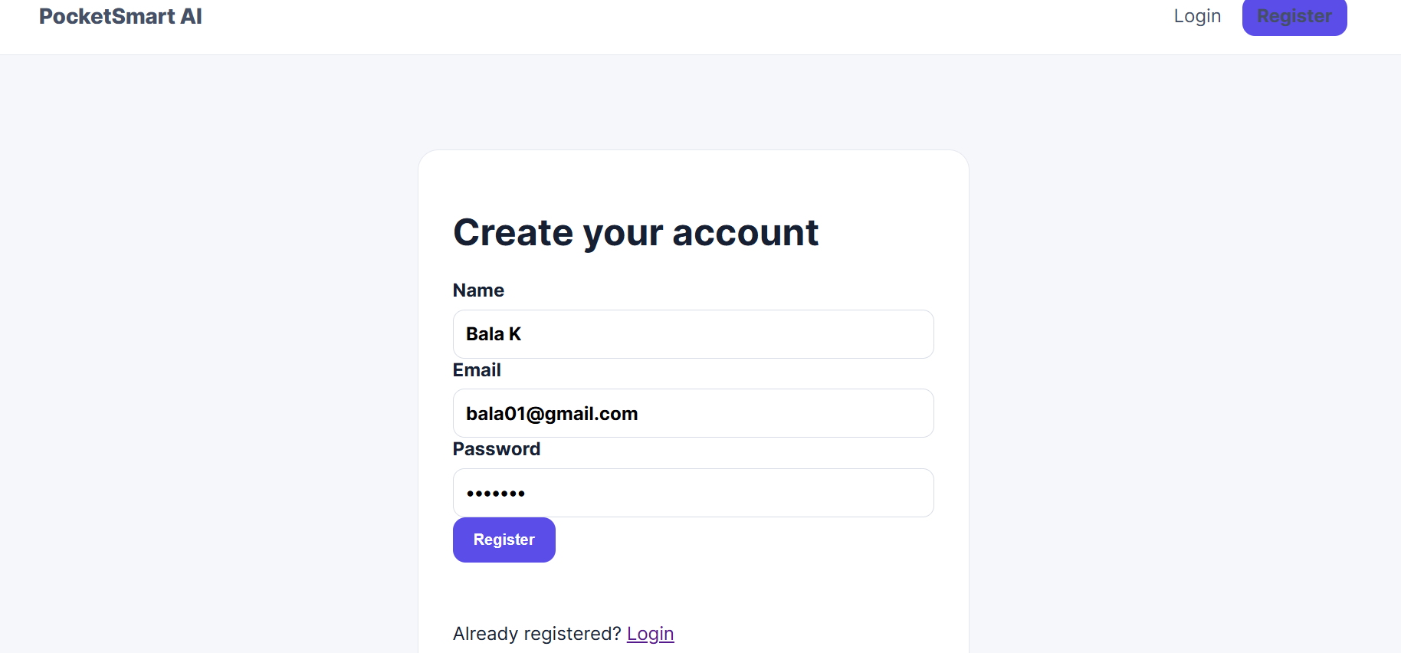
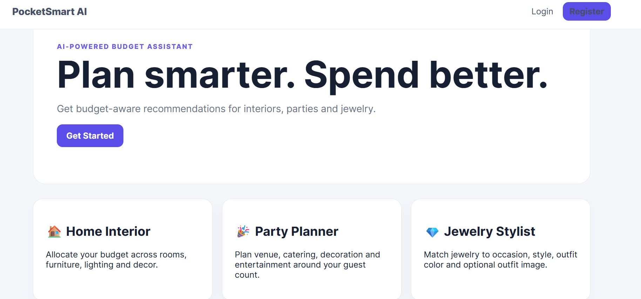
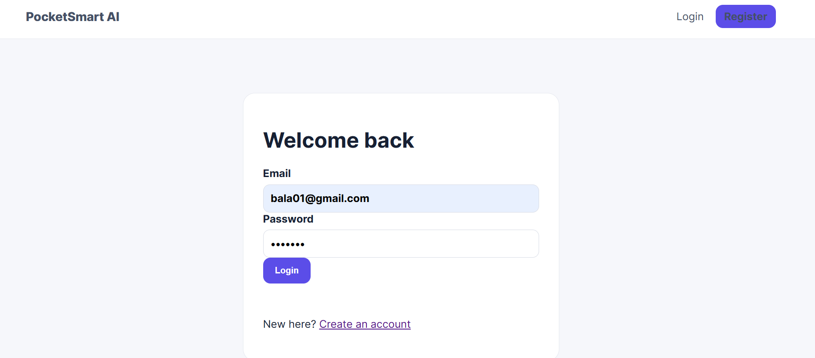
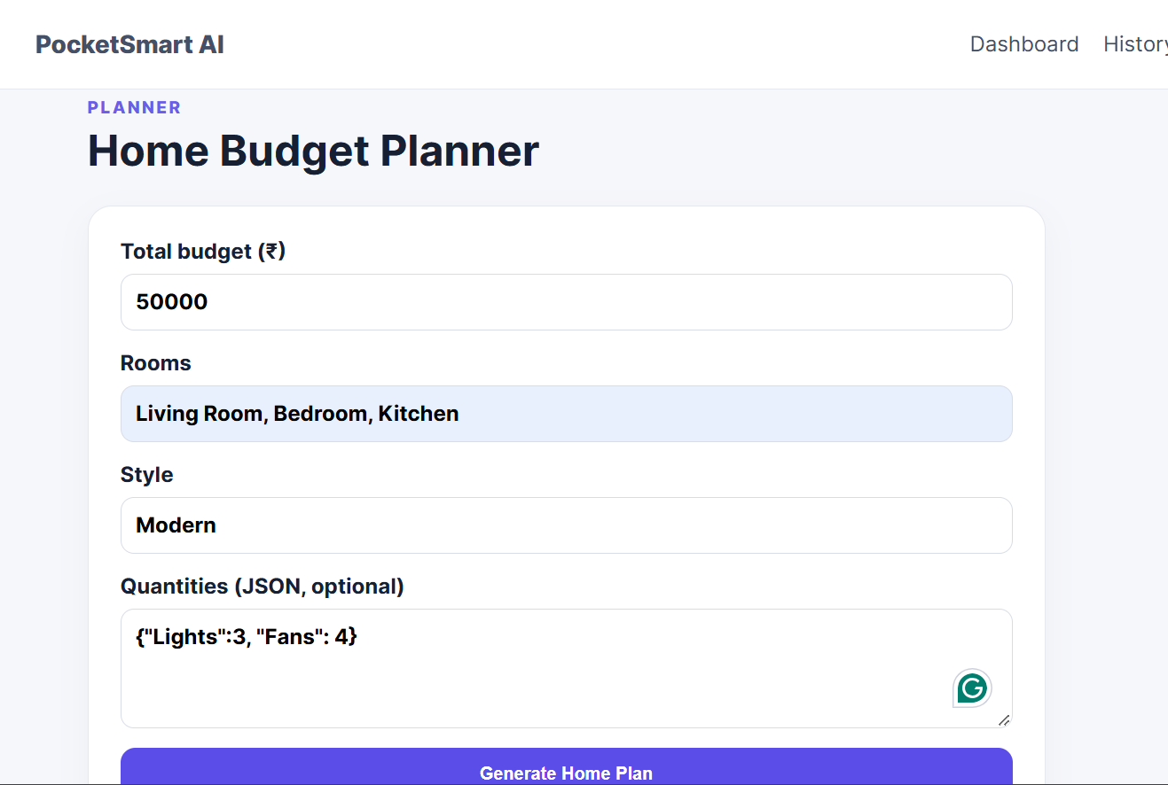
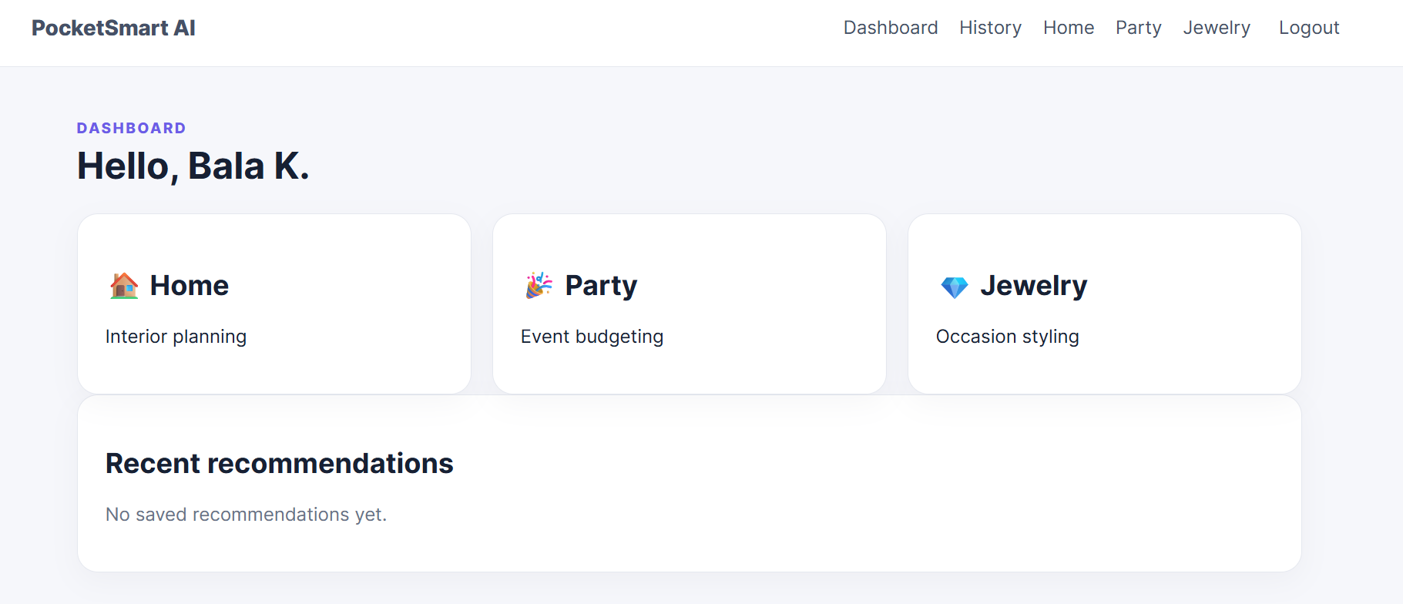
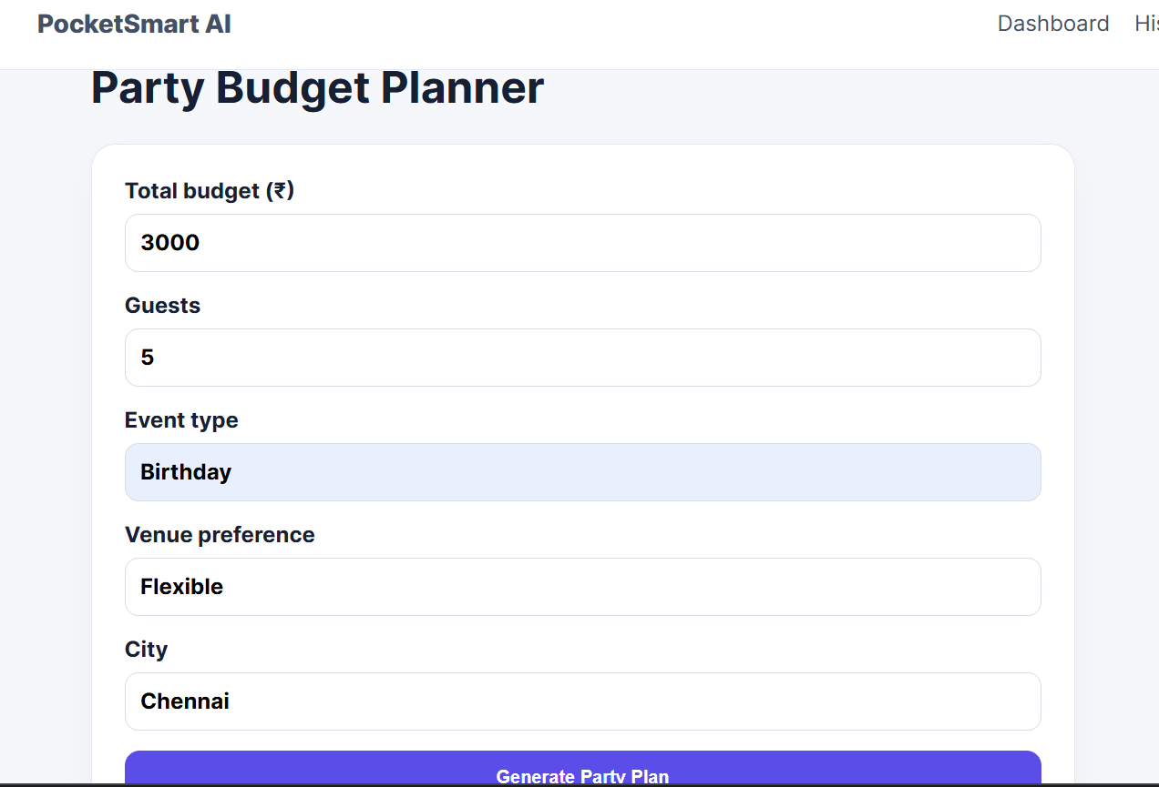

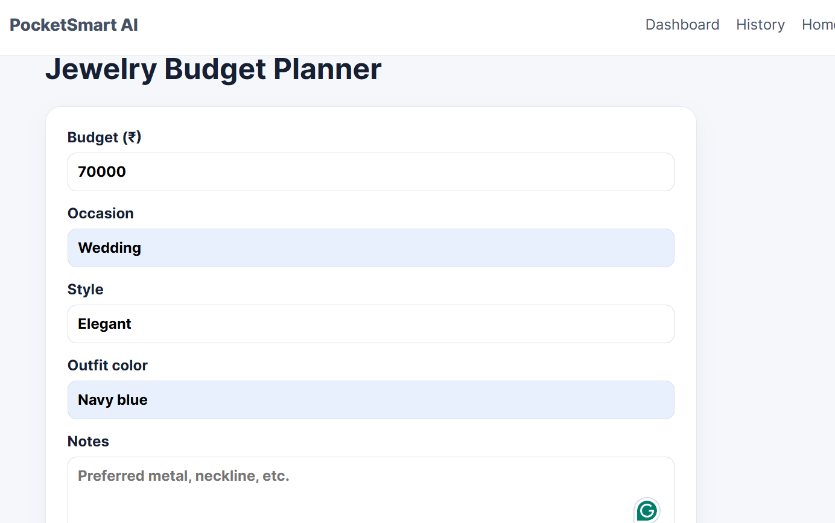

Milestone 5: Testing & Optimization
This milestone validates the reliability, accuracy, and contextual awareness of PocketSmart AI's recommendation engine.
- Activity 5.1: Test with Real-World Budget Inputs Across Domains
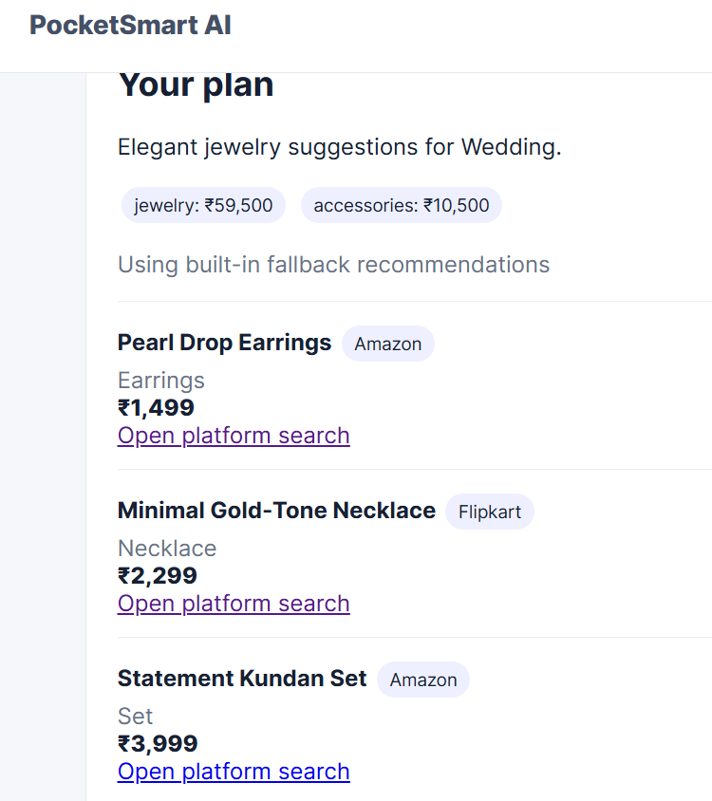
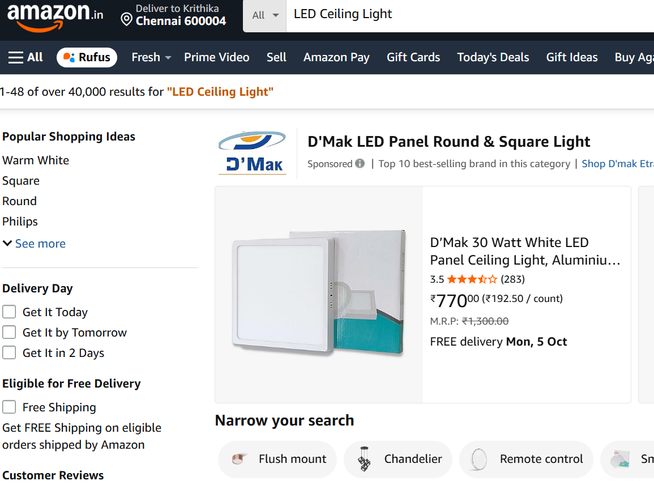
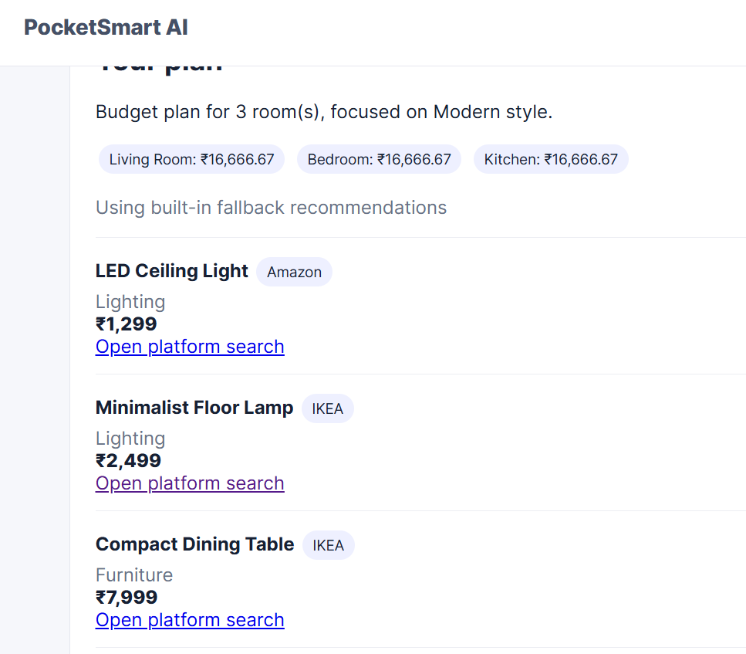
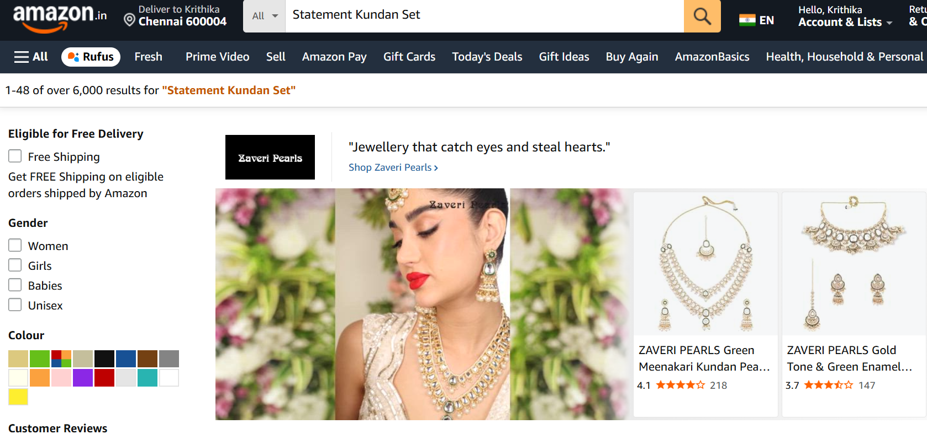
  - Conduct end-to-end verification using varied budgets across home decor setups, party packages, and outfit-matched jewelry suggestions.
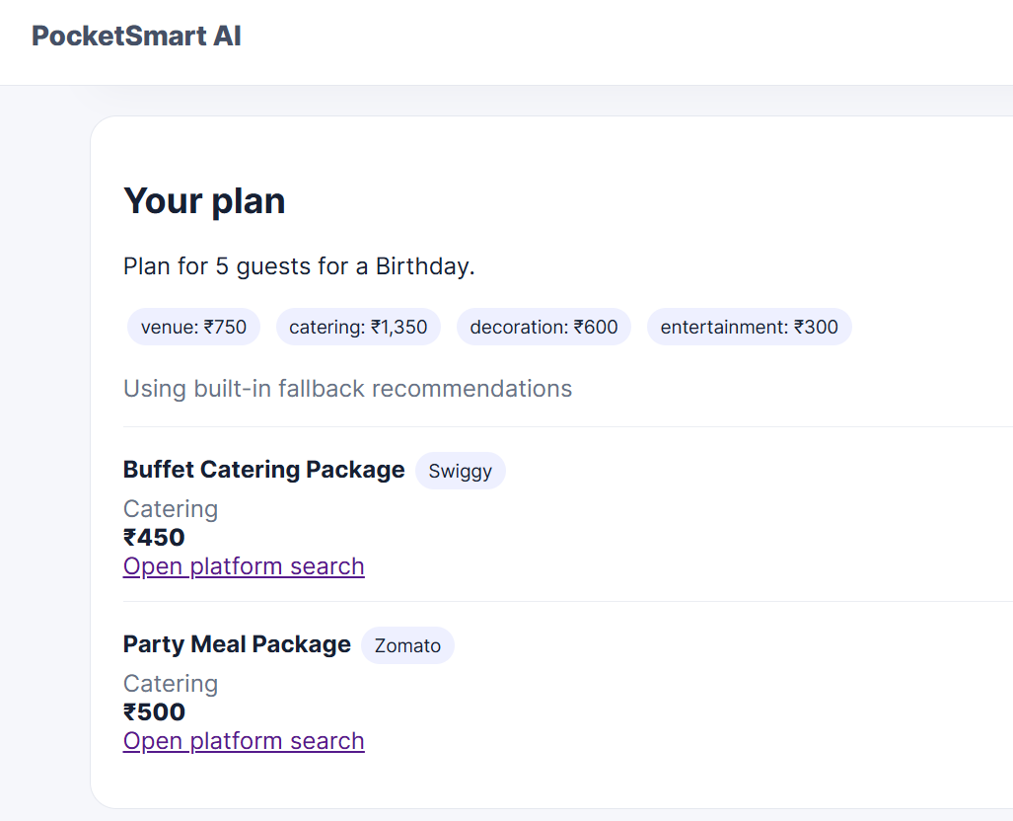
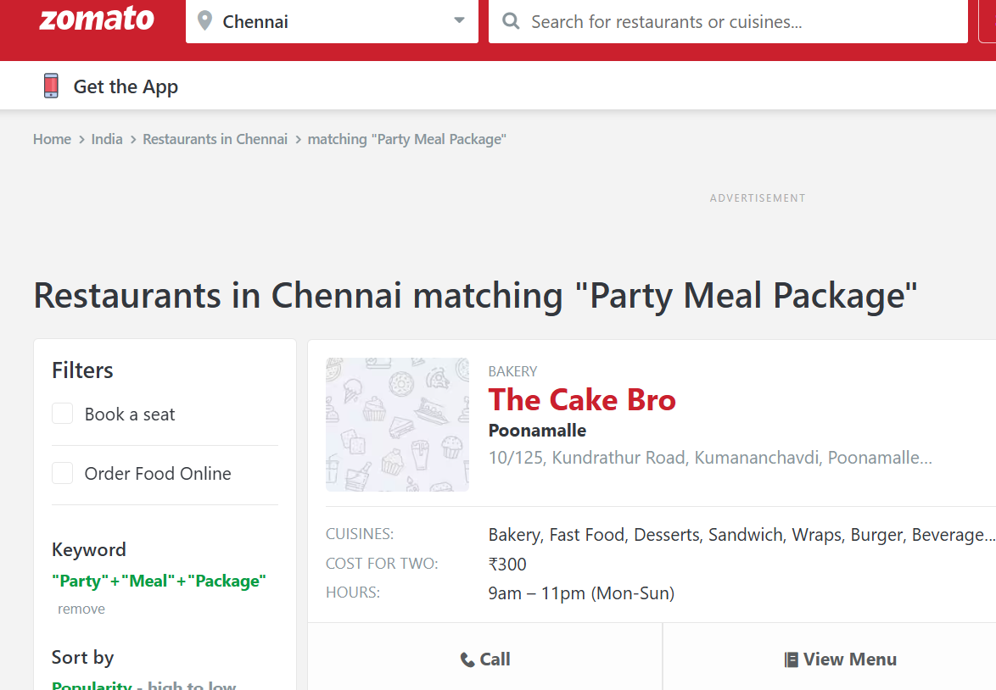

Conclusion
PocketSmart AI redefines the way individuals plan budgets for everyday lifestyle needs by delivering smart, AI-driven recommendations across home interiors, party planning, and jewelry selection. By combining the power of FastAPI with Gemini 1.5 Flash Pro, the system intelligently processes user inputs—budgets, preferences, and even images—to generate accurate and context-aware suggestions from multiple trusted platforms like Amazon, Flipkart, IKEA, Swiggy, Zomato, OYO, and more. From backend architecture to AI integration and a responsive frontend, PocketSmart AI has been built with a focus on efficiency, scalability, and user-centric design. With its seamless fusion of generative AI and web technologies, PocketSmart AI stands as a practical example of how AI can enhance everyday decision-making, bringing intelligent recommendations to users' fingertips.

